 April 30, 2010
U.S. DEPARTMENT OF COMMERCE

National Oceanic and Atmospheric Administration

NOAA Ship Oscar Dyson - R224

1801 Fairview Ave East, Seattle, WA 98102

Charlie Ratliff
Mountain View Elementary School
36803 Allder School Road
Purcellville, VA 20132

Dear Charlie,

Yes, I am the Captain of the Oscar Dyson. I have worked for NOAA since 1988 and have been a NOAA diver since 1989. I sailed on the Miller Freeman from 1996 to 1998, the Ronald H. Brown 2002 to 2004, and Ka’imimoana in 2005.

In February 2008, the albino killer whale was seen in the western Aleutians fisheries survey. The white killer whale was spotted with its pod about two miles off Kanaga Volcano, part of Alaska's Aleutian Islands. At the time, the Dyson was on a research expedition assessing pollock fish stocks near Steller sea lion haul-out sites. Have you read Moby Dick by Herman Melville – it is a story about an albino Sperm Whale?

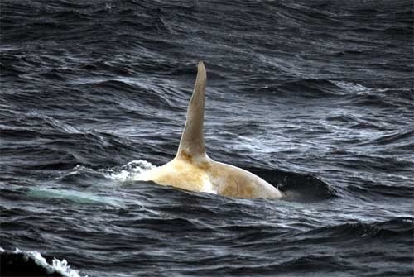
White killer whale swimming with its pod near the Aleutian Islands
Photo credit: H. Fearnbach, NMML, NMFS permit 782-1719

The Dyson was the first NOAA ship to launch an unmanned aircraft. Here’s an image of one of the launchings
.
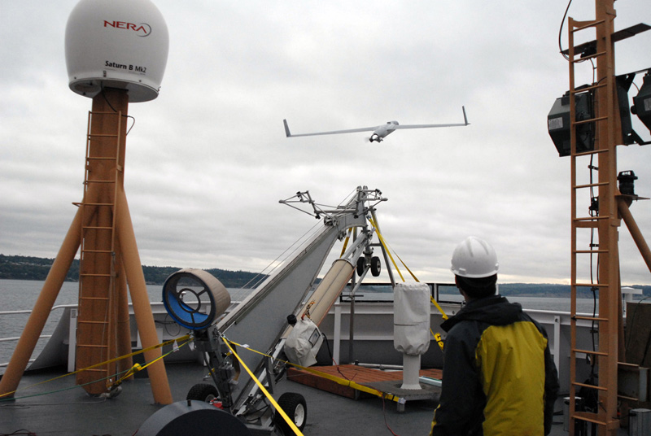

The aircraft was later used on a Bering Sea ice seal survey. Once the ship is in the sea ice it is difficult to cover as many miles and it is hard to see the seals in amid the jumbled pieces of sea ice. The aircraft allows scientists the ability to look for seals from above with the camera onboard the aircraft.

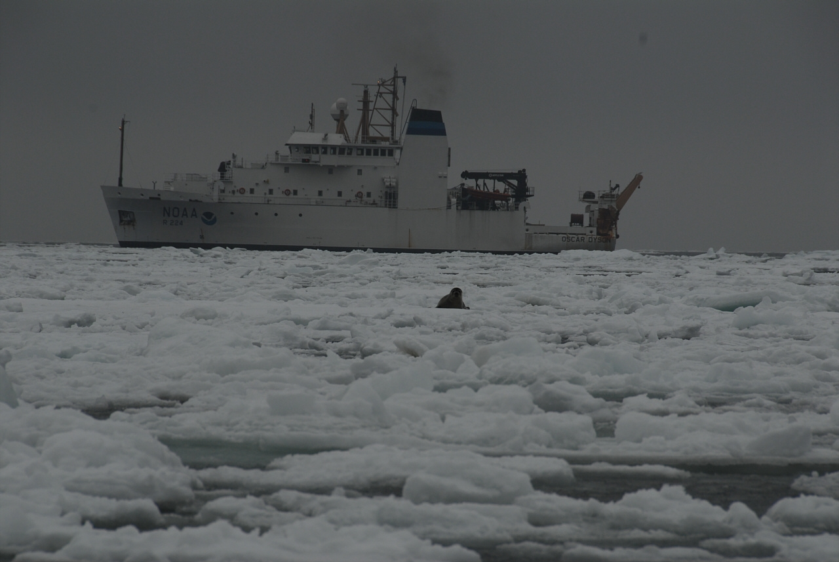

The Dyson spends a lot of time in the Bering Sea and goes into port in Dutch Harbor on Unalaska Island. You may have seen what Dutch Harbor is like from The Deadliest Catch television series about Bering Sea crab fishermen. Being on the ship provides unique experiences, in this remote area you see the many mountains, glaciers and volcanoes of the SW Alaska peninsula and Aleutian Island chain. In 2008, for example, we say the Okmok volcano eruption on Umnak Island. We routinely see marine mammals like Right, Sei, Fin, Minke, and Humpback whales, as well as many different kinds of sea birds, seals, and sea lions. Last year, we even saw walrus.

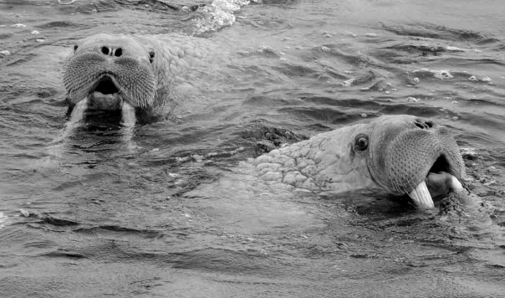

Oscar Dyson’s wife Peggy Dyson, provided significant contributions as well by aiding mariners and fishermen with daily weather forecasts in the Bering Sea and Gulf of Alaska. Our workboat is named Peggy D. We experience a lot of rough weather up here. It can be fun, it can also be tiring, when the weather is rough and the boat gets tossed about by the swell and waves and it is hard to sleep. Hurricane force wind gusts are something we get used in the winter and fall.

Response to your other questions: 1.) “Have any NOAA ships been destroyed or wrecked?
No NOAA ships have been destroyed or wrecked. Accidents, however, do occur. In 2006, the Oscar Dyson while transiting the Inside Passage in British Columbia ran onto a shoal area in a narrow channel. One of the blades of the propeller was sheared off when the blade hit the rock shoal. The resulting damaged required being placed in a drydock repair to fix the damage. In 2000, the Ronald H. Brown had an allision with an Inside Passage island's rocky shoal also resulting in damage requiring drydock repair.

2.) What is the point of sending NOAA ships to sea? NOAA has multiple survey mission and research priorities The NOAA ships provide a sea going platform to accomplish hydrographic surveys (chart water depth to update nautical charts), oceanographic and atmospheric research (to study climate change and pollution), and fisheries research vessels (to study fish stock population health and associated oceanography & ecology). Surveys aid safer navigation and research improves understanding of the earth’s processes and the ocean’s resources.

Hope you find a good use for your shrunken cup.
Best regards,
Captain Mike

